**INTRODUCTION**

Brief Introduction

According to Rosenberg potential [evapotranspiration](https://www.sciencedirect.com/topics/earth-and-planetary-sciences/evapotranspiration) (abbreviated as ETP by him, but as PET by most others) is “the evaporation from an extended surface of [a] short green crop which fully shades the ground, exerts little or negligible resistance to the flow of water, and is always well supplied with water.2. This actually refers to the amount of evaporation that would occur if a sufficient water source were available.1. Potential evapotranspiration is affected by the surface and air temperatures, insolation ad wind. According to Wikipedia a dryland is a place where annual potential evapotranspiration exceeds annual precipitation. The reason why evapotranspiration is important in the water cycle is because it is**responsible for 15% of the atmosphere’s water vapor.3. One must know that if there are no water vapor clouds do not form thus affecting rainfall and precipitations.3.**

**Background of Study**

**According to Diego G Miralles, it was only** in the late 1940s, did the term appear as “evapotranspiration” for the first time in literature. It was in 1948, when the American geographer and climatologist**Charles Thornthwaite** presented the notion of (potential) “evapotranspiration” and an empirical formulation to calculate it (Thornthwaite, 1948).(4). In the sixteenth century, Bernard Palissy, a Huguenot famous for his diverse contributions to art and science, was among the first to use the term in the vernacular with the specific meaning of “vaporization from land,” including transpiration (Palissy, 1580, [**1957**](https://agupubs.onlinelibrary.wiley.com/doi/10.1029/2020WR028055#wrcr24944-bib-0020)).

There have been a number of methods for calculating evapotranspiration. Some of these methods are based on an empirical correlation with monthly air temperature [THORNTHWAITE (1948), BLANEY (1951)]. MAKINK (1955) shows that the curve of the monthly values calculated according to THORNTHWAITE agrees with the observed potential evapotranspiration only after application of a correction for a time lag and for the wind velocity. No method based on monthly temperature alone can be expected to give reliable results for different regions [VAN WIJK and DE VRIES (1954)]. PENMAN (1948) has evolved a formula on a basis of sound physical reasoning. Recently MAKKINK (1957b) published a correlation formula with incoming radiation and air temperature. TURC (1954b, 1955) has constructed a correlation formula for evapotranspiration in which he uses rainfall, temperature and radiation. HAUDE (1952, 1954) makes use of an empirical formula principally based on the saturation deficit at 14.00 p.m. In this report we will be looking into about 4 methods.

Problem Statement

Calculating of potential evapotranspiration helps to know the amount of evaporation that could occur and it is very important in climate analysis and developing of climate programs and technology. There is not enough data concerning potential evapotranspiration at various stations/places in Ghana using climate data. Therefore, it has become imperative to do this thesis.

Significance of Study

This study is of much importance because, it will help hydrologist and weather experts to find solutions to drought, flooding etc. Also develop technology that could be useful for irrigation.

Objectives of Study

**The main aim of this study is to make a comparison between the various potential evapotranspiration formulas using Penman-Monteith as the base and find which of the formulas best suits.**

**Specific objectives**

1. **Identify various potential evapotranspiration formulas.**
2. **Focus on Penman- Monteith**
3. **Compare and find the best suits between the Penman-Monteith and other potential evapotranspiration formulas.**

**Brief Methodology**

**For calculating potential evapotranspiration there are five methods we will be looking at. These five methods are Hargreaves, Priestly Taylor, Blaney Criddle, Jenson Haise and the** Thornthwaite equation. However, we will be focusing on the Penman equation and comparing the results with the other four equations mentioned above. Also, an R script will be generated to help calculate for the potential evapotranspiration formulas.

**Literature Review**

Historical Background

PET requires a large number of input climate variables, many of which were not available before to the 1960s in the UK, or indeed in most parts of the world. Maliko Tanguy (Maliko Tanguy, 2018). Thornthwaite initially defined evapotranspiration, both actual and potential, in 1944, and his 1948 article, in which potential evapotranspiration was estimated as a complex empirical relationship of air temperature and day duration, made the term well known and used. (K. Novick and G. Katul, 2009). There is currently no easily available PET time series for researching long-term variability and change in hydrological regimes prior to the 1960s, such as water resource availability and drought patterns. Maliko Tanguy (Maliko Tanguy, 2018). This is a significant roadblock since historical drought periods are employed in water resource and drought planning (Watts et al., 2012), as well as for establishing a baseline of previous hydrological variability for future change assessments. In practice, however, the lack of atmospheric variables makes utilizing the Penman–Monteith equation to account for the majority of evapotranspiration processes prior to 1960 impossible. Maliko Tanguy (Maliko Tanguy, 2018).

**Potential evapotranspiration definition**

Potential evapotranspiration is the sum of soil evaporation and plant transpiration. It only happens at the maximum rate when the amount of water available for the process is not limited.

**Factors affecting potential evapotranspiration**

The rate of evaporation is affected by climatic factors such as the sun's radiative energy, wind, the air's vapor deficit, and temperature.

**Importance and use of measuring potential evapotranspiration**

Potential evapotranspiration is an important parameter in hydrological modeling. Evapotranspiration (ET) plays an important role in maintaining water balance of terrestrial ecosystem. Accurate assessment of evapotranspiration is essential for efficient irrigation management, water resources management, crop production, environmental assessment, ecosystem modelers and solar energy system.

**Potential evapotranspiration formulas**

Many approaches for estimating PET have been described to date; however, due to the scarcity of observable data, it is difficult to identify the best one. As a result, a number of comparison studies and assessments of various methodologies have been carried out. The Penman Monteith equation is frequently used to determine potential evaporation from these measurements. It can also be calculated using simple formulae like Thornthwaite's from publicly available rainfall and temperature data, which has been done for more than sixty years. Thornthwaite, C. W. (1955).

**METHODOLOGY**

STUDY AREA

The study area for this thesis was the Hydro-Meteorology Station of the Council for Scientific and Industrial Research, Water Research Institute. The hydro- meteorological station at CSIR-WRI records data on rainfall, temperature, evaporation, sunshine duration and wind speed and direction. The station is located 05̊ 35705N and 00̊ 11105 W at an altitude of 45.72m and data is digitally stored. The objective of the station is to describe the environmental conditions at any particular time and to determine water balance of the area**.**

DATA COLLECTION

Data to be analyzed was collected from the hydro meteorological station. Data collected and recorded from the meteorological station included rainfall data, temperature, wind speed, sunshine duration and evaporation. Various formulas and variables were obtained from the internet.

DATA ANALYSIS

Data was analyzed using R Software. This was used to analyze data collected from the hydro meteorological station. Data was entered into the R software and then run to get the values for potential evapotranspiration.

**METHODS DESCRIPTION**

Five evapotranspiration methods were selected to be compared against the Penman Monteith equations. These formulas are the Hargreaves, Priestly Taylor, Blaney Criddle, Jensen Haise and the Makkink Equations.

Blaney Criddle

The Blaney-Criddle (1950) procedure for estimating ET is well known in the

western U.S.A. and has been used extensively elsewhere also (Singh, 1989). The

usual form of the Blaney-Criddle equation converted to metric units is written as:

ET = kp (0.46Ta + 8.13),

where

ET = potential evapotranspiration from a reference crop, in mm, for the

period in which p is expressed;

Ta = mean temperature in ◦C;

p = percentage of total daytime hours for the used period (daily or monthly) out of total daytime hours of the year (365 × 12);

k = monthly consumptive use coefficient, depending on vegetation

type, location and season and for the growing season (May to October), k varies from 0.5 for orange tree to 1.2 for dense natural vegetation.

Hargreaves Method

Hargreaves and Samani (1982, 1985) proposed several improvements to the Hargreaves (1975) equation for estimating grass-related reference ET (mm d−1); one

of them has the form:

ET = aRaT D1/2

(Ta + 17.8) , (17)

where

a = 0.0023 is a parameter;

T D = the difference between maximum and minimum daily temperature in ◦C;

Ra = the extraterrestrial radiation expressed in equivalent evaporation units. For a given latitude and day Ra is obtained from tables. The Hargreaves method has become a

temperature-based method.

Jensen Haise.

The Jensen-Haise equation (cal/cm2/d) represents a temperature-radiation method of calculating

a daily ETr.

The Jensen Haise equation is as follows;

λ ET r = CT (T mean -TX ) Rs

where:

CT is the temperature coefficient.

Tmean is the daily mean temperature in EF.

Tx is the intercept of the temperature axis.

Rs is the measured global solar radiation in cal/cm2/day

The product of CT(T -T ) represents a weighting function on Rs.

Priestly Taylor

The Priestley-Taylor equation is expressed as (Sediyama et al., 1997):

ETo = α.W. (Rn – G) where α is the calibration constant, which is equal to 1.26

Makkink equation

The Makkink equation is expressed as (Sediyama et al., 1997):

ETo = 0.61 W.Rs – 0.12

W = Δ/( Δ + γ)

where W is the index that depends on the psychrometric constant

γ (kPa.K-1) and slope of the vapor pressure curve Δ (kPa.K-1)

**Study Region and Data**

The Water Research Station in the Greater Accra region in Ghaa was used in this study. This station is located at latitude of 05°35.705´N and a longitude of 00°11.105´W. Several hydro meteorological variables, including air temperature, grass temperature, soil temperature however was assumed to be 0, wind speed, relative humidity, solar radiation and vapour pressure among others have been recorded for the period January to December in 2000. The area is predominantly surrounded by grass land.

**RESULTS AND DISCUSSION**

In the first stage of the comparative study, daily evapotranspiration from Penman Montieth method and other 4 emperical methods that is the ,Jensen Makkink, Hargreaves and Priestly Tailor.

|  |  |  |  |  |  |
| --- | --- | --- | --- | --- | --- |
| Months | penman | hargreaves | makkink | taylor | JENSEN |
| January | 6.410033 | 0.786445 | 0.323341 | 0.19467 | 1.003794 |
| February | 11.88118 | 0.819688 | 0.338056 | 0.22833 | 1.049838 |
| March | 9.178101 | 0.843027 | 0.343006 | 0.207163 | 1.087002 |
| April | 8.939684 | 0.806723 | 0.328575 | 0.208938 | 1.035242 |
| May | 6.929523 | 0.752281 | 0.305147 | 0.199524 | 0.959231 |
| June | 5.283575 | 0.701776 | 0.292048 | 0.199773 | 0.880963 |
| July | 5.406952 | 0.689692 | 0.296748 | 0.208309 | 0.855205 |
| August | 5.008467 | 0.722142 | 0.318668 | 0.211062 | 0.893365 |
| September | 5.760151 | 0.777726 | 0.338417 | 0.2099 | 0.974712 |
| October | 7.830537 | 0.803066 | 0.33961 | 0.212053 | 1.018812 |
| November | 8.353144 | 0.791869 | 0.326398 | 0.209209 | 1.010716 |
| December | 7.130551 | 0.76976 | 0.317771 | 0.20269 | 0.979051 |

**Table 1: Evapotranspiration for the year 2000**

Monthly evapotranspiration values comuted from four empirical methods were first compared with the Penman-Monteith values (Figure 1). A visual comparison reveals that the Penman-Montieth values are relatively higher than the other evapotranspiration methods this may be due to the wind speed value which is high in the Penman Montieth equation. I order to have a quantitative evaluation, the correlations between the four empirical methods and the Penman-Montieth estimates were analyzed using a linear regression equation.

Y =Mx + c

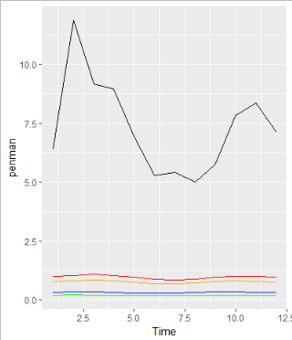

**Figure 1:Graph of Evapotranspiration**

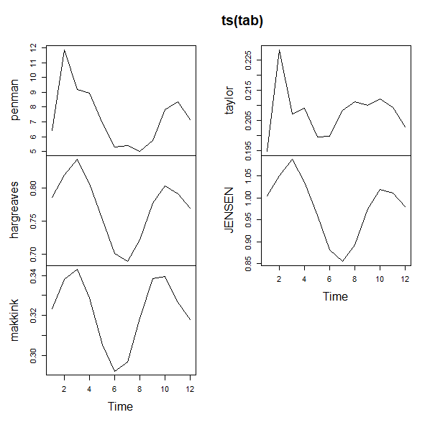

**Figure 2: Time series of Evapotranspiration**

Where Y represents ET computed by Penman-Montieth Equation (1) and X is the ET estimated from the above-mentioned four methods, and m and c are constants representing the slope and intercepts of the regression equation, respectively. The resulted regression equations together with the cross-correlation (R2) are presented in Figure 3. When the determination coefficient R2 values are concerned,

Correlation between Penman and Makkink

|  |  |
| --- | --- |
| Pearson's product-moment correlation  data: penman and makkink  t = 2.4911, df = 10, p-value = 0.03193  alternative hypothesis: true correlation is not equal to 0  95 percent confidence interval:  0.06964054 0.88014170  sample estimates:  correlation :0.6188103  Coefficients:  (Intercept) makkink y = 73.34x -16.3  -16.30 73.34  R2 = 0.383 | Pearson's product-moment correlation  data: penman and hargreaves  t = 4.246, df = 10, p-value = 0.0017  alternative hypothesis: true correlation is not equal to 0  95 percent confidence interval:  0.4226335 0.9422272  sample estimates:  correlation: 0.802008  Coefficients:  (Intercept) hargreaves y = 34.15x -19.02  -19.02 34.15  R2 = 0.643 |
| Pearson's product-moment correlation  data: penman and taylor  t = 2.5718, df = 10, p-value = 0.02781  alternative hypothesis: true correlation is not equal to 0  95 percent confidence interval:  0.08943649 0.88455334  sample estimates:  correlation: 0.6309527  Coefficients:  (Intercept) taylor y = 150.28x -23.86  -23.86 150.28  R2 = 0.398 | Pearson's product-moment correlation  data: penman and JENSEN  t = 4.5147, df = 10, p-value = 0.001117  alternative hypothesis: true correlation is not equal to 0  95 percent confidence interval:  0.4626265 0.9475558  sample estimates:  correlation :0.8190647  Coefficients:  (Intercept) JENSEN y = 23.22x -15.39  -15.39 23.22  R2 = 0.671 |

The association between the Penman and the other ways of determining Evapotranspiration was determined using the aforesaid regression analysis. The linear relationship equation, as well as the correlation coefficient and coefficient determination, were determined. The Jensen and Hargreaves approaches exhibited a substantial positive connection according to Penman. This could be related to the fact that both approaches are based on temperature. There appear to be some similarities between the Jensen and Hargreaves graphs (Figure 2). And this may be demonstrated by assuming that during the two rainy seasons in 2000, the minor rainy season is from March to May, and the main rainy season is from June to August. Using temperature-based methodologies, the results show that potential evapotranspiration falls throughout the rainy season. This is owing to the fact that, due to the rise in humidity, the rate at which water is lost to the environment during the rainy season is low. However, given the elements of the Hargreaves and Jensen approaches, a linear equation has been devised to derive the Penman Equation. This is because both of these methods require temperature-based inputs to be computed.

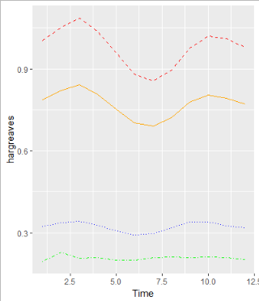

**Figure 4: Plots of Jensen, Hargreaves, Makkink, Taylor respectively.**

**ggplot()+**

**geom_line(data = tab,mapping = aes(Time,hargreaves),colour = "orange" ,lty = 1)+**

**geom_line(data = tab,mapping = aes(Time,JENSEN),colour = "red",lty = 2)+**

**geom_line(data = tab,mapping = aes(Time,makkink),colour = "blue",lty = 3)+**

**geom_line(data = tab,mapping = aes(Time,taylor),colour = "green",lty = 4)**

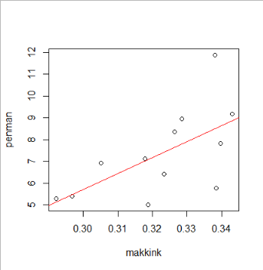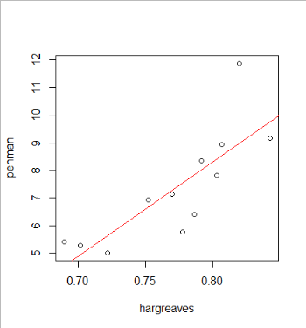

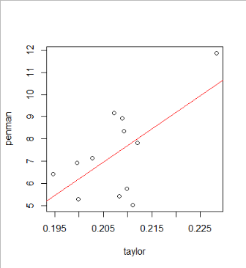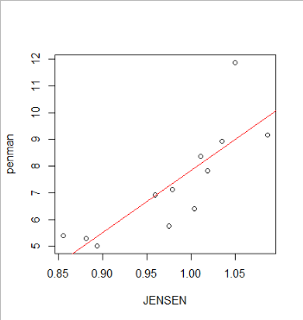

**Figure 3: Regression Analysis on Penman and other 4 empirical methods.**

The Makkink and the Priestly Taylor are two radiation-based procedures that are based on energy balances. Makkink and Priestly Taylor, according to the FAO -24, assist in calculating potential evapotranspiration given various radiation parameters. So the Net Radiation, Solar Radiation, and latent heat of vaporization were calculated using the meteorological station at the WRI. Penman and the other two temperature-based approaches have a less strong association. Also, the coefficient of determination, which measures the intensity of the link, shows that about 30% of the differences between Penman and radiation-based readings are related. This suggests that 70% of the variables have nothing to do with the Penman method's results. Furthermore, because of the multiple inputs, the weather station is more of a temperature-based weather station, as more temperature data are recorded. Given the grassland flora around the weather station, it was also best to employ temperature-based approaches. Also, the soil heat flow, which could have aided the radiation-based method, was estimated to be zero for daily temperatures and hence presumed to be zero for monthly values.

**Conclusion**

It can be observed that the best method to use in place of the Penman Equation is the Jensen and Hargreaves. This is because they are strongly similar to the Penman Equation. However any of the equations can be used given the linear models given.

References

Palissy, B. (1957). Admirable discourses [1580], trans. A. *A. La Rocque: University of Illinois Press, Urbana.[Google Scholar]*.

BLANEY, H. F. 1951. Irrigation requirements of crops. Agr. Eng. 32: 665

HAUDE, W. 1952. Verdünstungsmenge und Evaporationskraft eines Klimas. Ber. Deutschen Wetterd. U.S. Zone 42: 225 1954. Zur praktischen Bestimmung der aktuellen und potentiellen Evaporation und Evapotranspiration. Mitt. Deutschen Wetterd. 8 1955. Zur Bestimmung der Verdunstung auf möglichst einfache Weise. Mitt. Deutschen Wetterd. 11

MAKKINK, G. F. 1955. Toetsing van de berekening van de evapotranspiratie volgens Penman. Landbouwk. Tijdschrift 67: 267 1957a. Testing the Penman formula by means of lysimeters. Journ. Inst. Water Eng. 11: 277 1957b. Ekzameno de la formulo de Penman. Neth. J. Agric. Sei. 5: 290

PENMAN, H. L. 1948. Natural evaporation from open water, bare soil and grass. Proc. Roy. Soc. A 193: 120 1956. Evaporation; an introductory survey. Neth. J. Agric. Sei. 4: 9 THORNTHWAITE, C. W. 1948. An approach toward a rational classification of climate